Pizza Order SP

In Northwind Database, create new table (“PizzaOrders” table), like following picture :

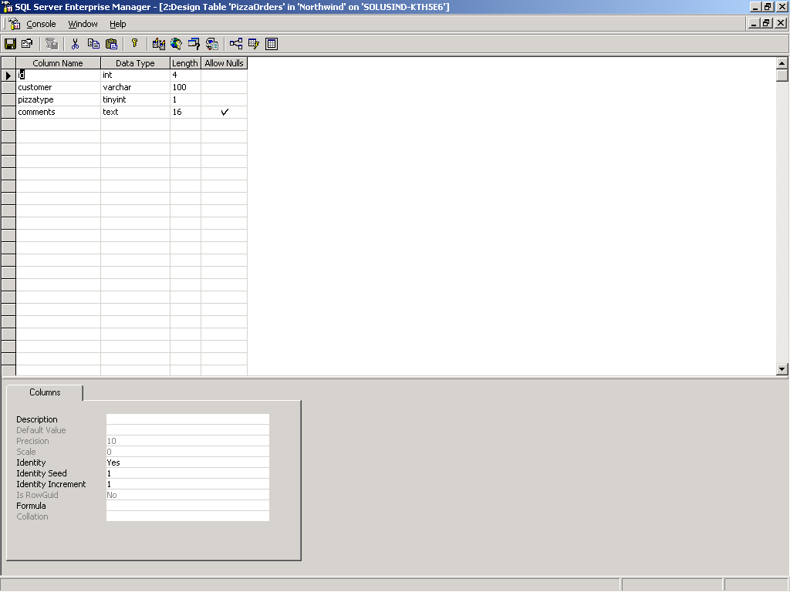

After you create “PizzaOrders” table in Northwind Database, then create procedure to Insert Pizza Orders.

InsertPizzaOrders Procedure

CREATE PROCEDURE dbo.InsertPizzaOrders
(
@customer varchar( 100 ),
@pizzatype tinyint,
@comments text
)
AS
Insert PizzaOrders
(
customer,
pizzatype,
comments
) Values (
@customer,
@pizzatype,
@comments )

